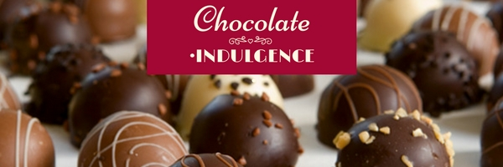

Champagne Truffles - $5,000 & up

Pre & Post Event Publicity Logo/Name prominently displayed in program
2 Reserved Tables for 16 - Prime Location 2 Exclusive Event Poster Boards with Logo
Large Table Signage Trays of hors d’oeuvres
Link to website on WIN’s webpage 2 Banners
2 bottles of White Wine 8 Social Media Blasts with website link
2 Bottles of Red Wine

Cognac Truffles - $3,000

1 Reserved Table for 8 in a Key Location 1 Exclusive Event Poster Board with Logo
Post Event Publicity Medium Table Signage
1 Bottle of Red Wine 2 Social Media Blasts with website link
1 Bottle of White Wine Logo & Name in Program

Irish Cream - $1,500

Reserved Table for 8 Shared Poster Signage
1 Bottle of Wine Table Signage
Logo in Program

Amaretto Truffles - $750

1 Table for 8 Small Table Signage
Name in Program

Kisses - $250

Name in Program 2 tickets

Individual Ticket - $120 Couple Tickets - $200

