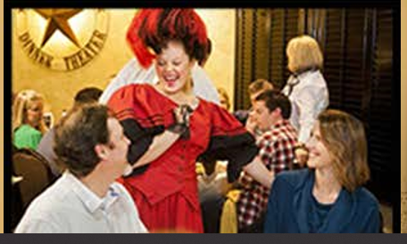
WOMEN IN NEED’S
2018
PRESENTING SPONSOR
L3 TECHNOLOGIES E-CLUB

Texas Ranger - $3,000

Banner - (Sponsor Provides) Pre & Post Event Publicity
2 Reserved Tables for 16 - Prime Location Logo & Name Prominently Displayed in Program
1 Personal Server Large Table Signage (8x10)
2 Bottles of Red Wine & 2 Bottles of White Wine Link to website on WIN’s webpage
Tray of Tapas 8 Social Media Blasts with website link

Marshall - $1,500

1 Reserved Table for 8 in a Key Location Logo & Name in Program
1 Bottle of White Wine Medium Table Signage (6x8)
1 Bottle of Red Wine 2 Social Media Blasts with website link

Sheriff - $1,000

Reserved Table for 8 Logo in Program
1 Bottle of Wine Table Signage (5x5)

