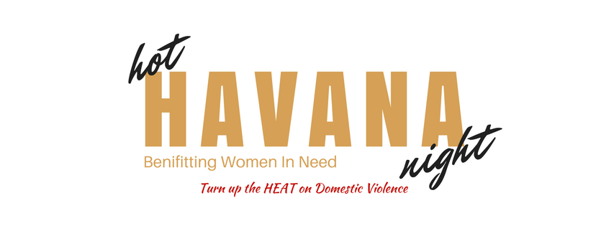

August 10th, 2019

Women In Need’s - 4rd Annual “Hot Havana Night”

Silent Auction Donor Form

Sponsor Name/Title/ Company/Organization:____________________________ Contact Person: ____________________________

Address: ____________________________________________________________________________________________________

City: ___________________________________________________ State: _________ Zip:_________________________________

Email: __________________________________________________ Daytime phone: ______________________________________

Delivery/Pick Up Address ____________________________________________________________________
Description of items (s) being donated: __________________________________________________________
__________________________________________________________________________________________________________________________________________________________________________________________________________________________________________________________________________________________________________________________________________________________________________________________________________________________________________________________________

Value of items (s): __________________________________________________________________________
__________________________________________________________________________________________
Is donor also a sponsor? _________________
THANK YOU FOR YOUR DONATION!
******************************************************************************
Office Use Only
Thanked ______________________________
Item (s) received/picked up _______________
Invitation mailed/delivered _______________
Signed Up By: _________________________

Contributions are tax deductible as allowed by Federal Law. For Information please call: Connie Pettitt 972.772.3000, 903.455.4512

